**SPRINT 3**

|  |  |
| --- | --- |
| Date | 12 November 2022 |
| Team ID | PNT2022TMID24244 |
| Project Name | Project – Smart Farmer-IoT Enabled smart Farming Application |

**Creating Mobile app using MIT app Inventor**

**SMART FARMER APPLICATION**

App Inventor + IoT can work together to help us understand, and change, our everyday lives.

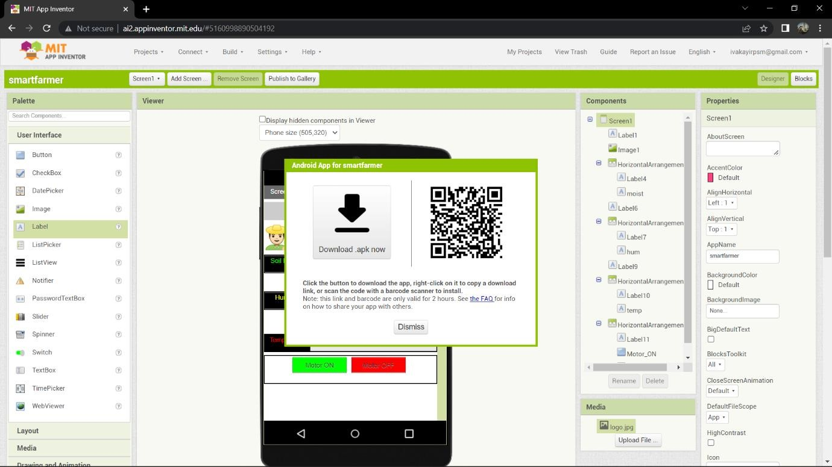**Blocks**

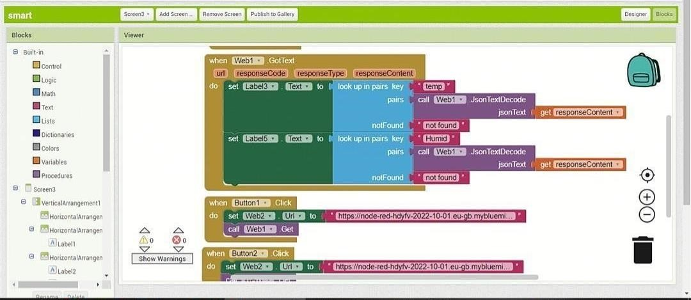

**QR Code for APK download:**

**Output Screen in Mobile :**

